Analysis of the Assignment

Table of Contents

**1.** **Monthly Trend analysis of Office supplies with Max & Min Profit (Focus on Qualitative data)** 4

**2.** **Trend analysis of Sales & Profit for Oceania region from 2014 – 2017 (Question 1)** 5

**3.** **Sales by State, City of Australia, New Zealand and Papua New Guinea for the year 2016 (Question 2)** 8

**4.** **Oceania region Sales and average Profit monthly analysis with Maximum and Minimum values from 2014 – 2017 (Question 3)** 9

**5.** **Appendix** 12

# **Monthly Trend analysis of Office supplies with Max & Min Profit (Focus on Qualitative data)**



Maximum profit is in (Red) and Minimum profit is in (Green)

As seen clearly from the above analysis, Appliances was the clear winner in terms of Maximum average Profit, out of 48 months Appliances has highest for 26 months among all Sub-Categories which is great.

For Minimum average profit, Fasteners has the least profit for most of the months, i.e., 15 months

As per the analysis, the reason for office supplies not giving that much profit is shipping cost, the shipping cost of the goods is very much high.

If we can find a way in which we can reduce shipping cost, we can maximise the profit for these Categories.

We can see Binders, envelopes, Fasteners, Labels are the emerging segments of the sub-categories, if we can lay an emphasis on these sub-categories to perform well.

# **Trend analysis of Sales & Profit for Oceania region from 2014 – 2017 (Question 1)**

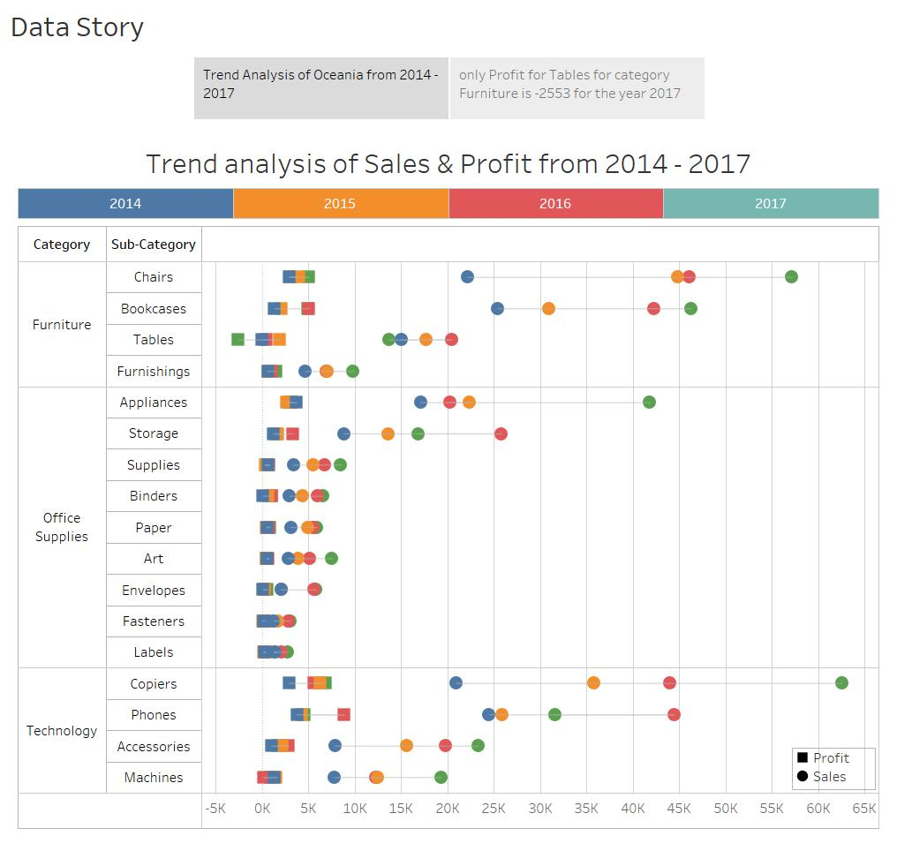

**Analysis:**

1. **Top-most Sales by Year:**
   1. 2014 – Category : Furniture, Sub-Category : Chairs
   2. 2015 – Category : Furniture, Sub-Category : Chairs
   3. 2016 – Category : Furniture, Sub-Category : Chairs
   4. 2017 – Category : Technology, Sub-Category : Copiers
2. **Top-most Profit by Year:**
   1. 2014 – Category : Technology, Sub-Category : Phones
   2. 2015 – Category : Technology, Sub-Category : Copiers
   3. 2016 – Category : Technology, Sub-Category : Phones
   4. 2017 – Category : Technology, Sub-Category : Copiers
3. **Bottom-most Sales by Year:**
   1. 2014 – Category : Office - Supplies, Sub-Category : Fasteners
   2. 2015 – Category : Office - Supplies, Sub-Category : Fasteners
   3. 2016 – Category : Office - Supplies, Sub-Category : Labels
   4. 2017 – Category : Office - Supplies, Sub-Category : Labels
4. **Bottom -most Profit by Year:**
   1. 2014 – Category : Furniture, Sub-Category : Tables
   2. 2015 – Category : Office - Supplies, Sub-Category : Fasteners
   3. 2016 – Category : Technology, Sub-Category : Machines
   4. 2017 – Category : Furniture, Sub-Category : Tables

If we do more analysis and drill down from year to monthly sales and Profit with Maximum and Minimum Sales and Profit Year and month and Category and Sub-Category, find the analysis done below:



Clearly, year 2017 has the maximum sales, in which Category – Technology and Sub-Category – Copiers has the maximum Sales, followed by Category – Furniture and Sub-Category – Chairs and Bookcases.



If we analyse the above Viz, the later half of the year 2016 and 2017 recorded the maximum Sales for the Sub-Categories,

The maximum is recorded in October 2017 by Copiers followed by Chairs in November 2017 and if we see the prior half from Jan to April-May for all the years recorded the lowest sales for most of the sub-categories.

Here the Trend Changes, Phones has the maximum profit for the year 2016, followed by Copiers and Chairs in 2017 and Tables recorded the least Profit for 2017 followed by Fasteners for 2015, envelopes and Binders for 2014.



Here the trend changes, for monthly analysis, Bookcases recorded the maximum Profit in June 2017, followed by Chairs in November 2017.

The least Profit was shown by Tables in June 2017 followed by Chairs in August 2017, if we see, the latter half of 2016 and 2017 after May – 2017 the count of least profit was shown by 9 Sub-Categories, so by this we can draw some conclusions that as the sales is maximum for these months we see a dip in Profit also for these months.

# **Sales by State, City of Australia, New Zealand and Papua New Guinea for the year 2016 (Question 2)**



Sales analysis for State and City for the Country Australia, New Zealand and Papua New Guinea



Here the list of the city with maximum and minimum sales:

For Australia, Sydney has the highest sales and Melton has the lowest Sales.

For New Zealand, Whakatane has the highest sales and Nelson has the lowest Sales.

# **Oceania region Sales and average Profit monthly analysis with Maximum and Minimum values from 2014 – 2017 (Question 3)**



As from the above Jedi Visualisation,

**For Furniture:**

* Average max Profit – June 2016 – 168.3
* Average min Profit – June 2014 – (-85.8)
* Max Sales –June 2017 - $21688
* Min Sales – February 2014 - $939

**For Office Supplies:**

* Average max Profit – March 2016 – 83.5
* Average min Profit – July 2015 – (-17.2)
* Max Sales – December 2016 - $13553
* Min Sales – March 2014 - $1230

**For Technology:**

* Average max Profit – December 2016 - 162
* Average min Profit – August 2017 – (-47.2)
* Max Sales – November 2017 - $21663
* Min Sales – April 2014 - $1186

1. **Monthly Cluster analysis of Profit and Sales**

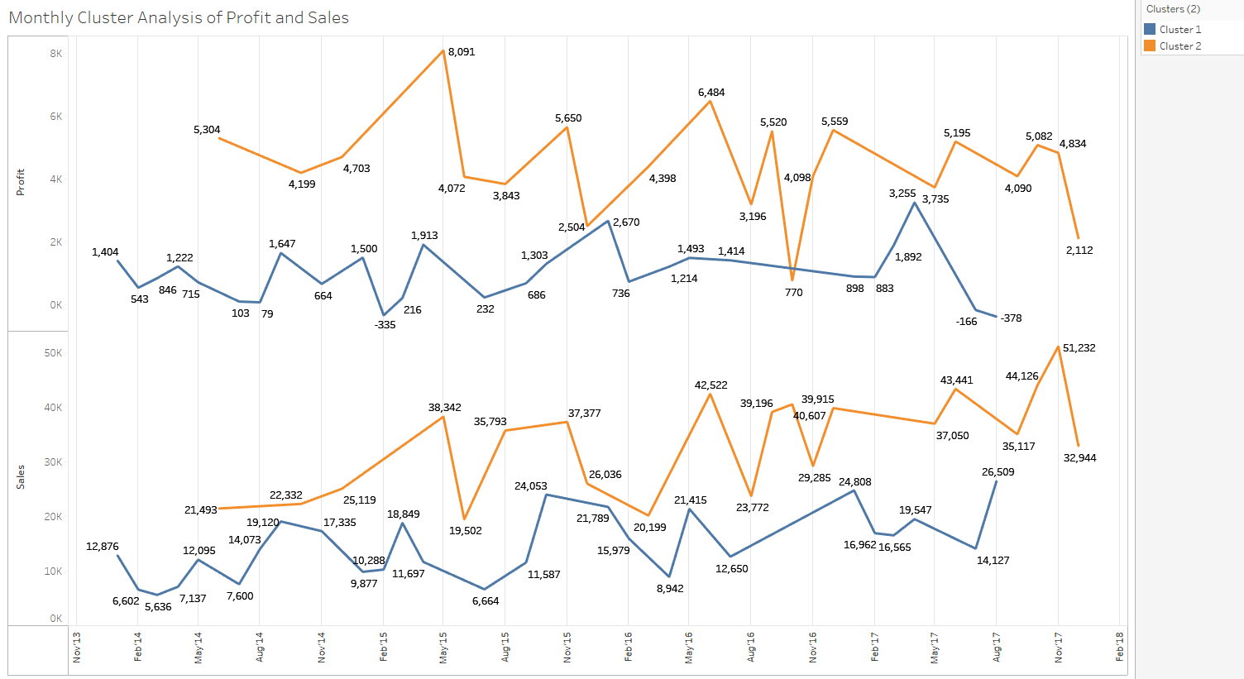

**Inputs for Clustering**

|  |  |
| --- | --- |
| **Variables:** | Sum of Profit |
|  | Sum of Sales |
| **Level of Detail:** | Month of Order Date |
| **Scaling:** | Normalized |
|  |  |

**Summary Diagnostics**

|  |  |
| --- | --- |
| **Number of Clusters:** | 2 |
| **Number of Points:** | 48 |
| **Between-group Sum of Squares:** | 4.0187 |
| **Within-group Sum of Squares:** | 2.2033 |
| **Total Sum of Squares:** | 6.222 |
|  |  |

|  |  |  |  |
| --- | --- | --- | --- |
| **Clusters** | **No. of Items** | **Total Profit** | **Total Sales** |
| Cluster 1 | 27 | 986.97 | 14622.00 |
| Cluster 2 | 21 | 4449.60 | 33591.00 |
| Not Clustered | 0 |  |  |

**Analysis of Variance:**

|  |  |  |  |  |  |  |
| --- | --- | --- | --- | --- | --- | --- |
|  |  |  | **Model Error** | | | |
| **Variable** | **F-statistic** | **p-value** | **Sum of Squares** | **DF** | **Sum of Squares** | **DF** |
| **Sum of Profit** | 31.04 | 1.265e-06 | 1.974 | 1 | 2.926 | 46 |
| **Sum of Sales** | 28.53 | 2.771e-06 | 2.044 | 1 | 3.296 | 46 |

1. **Monthly Forecasting of Sales and Profit**

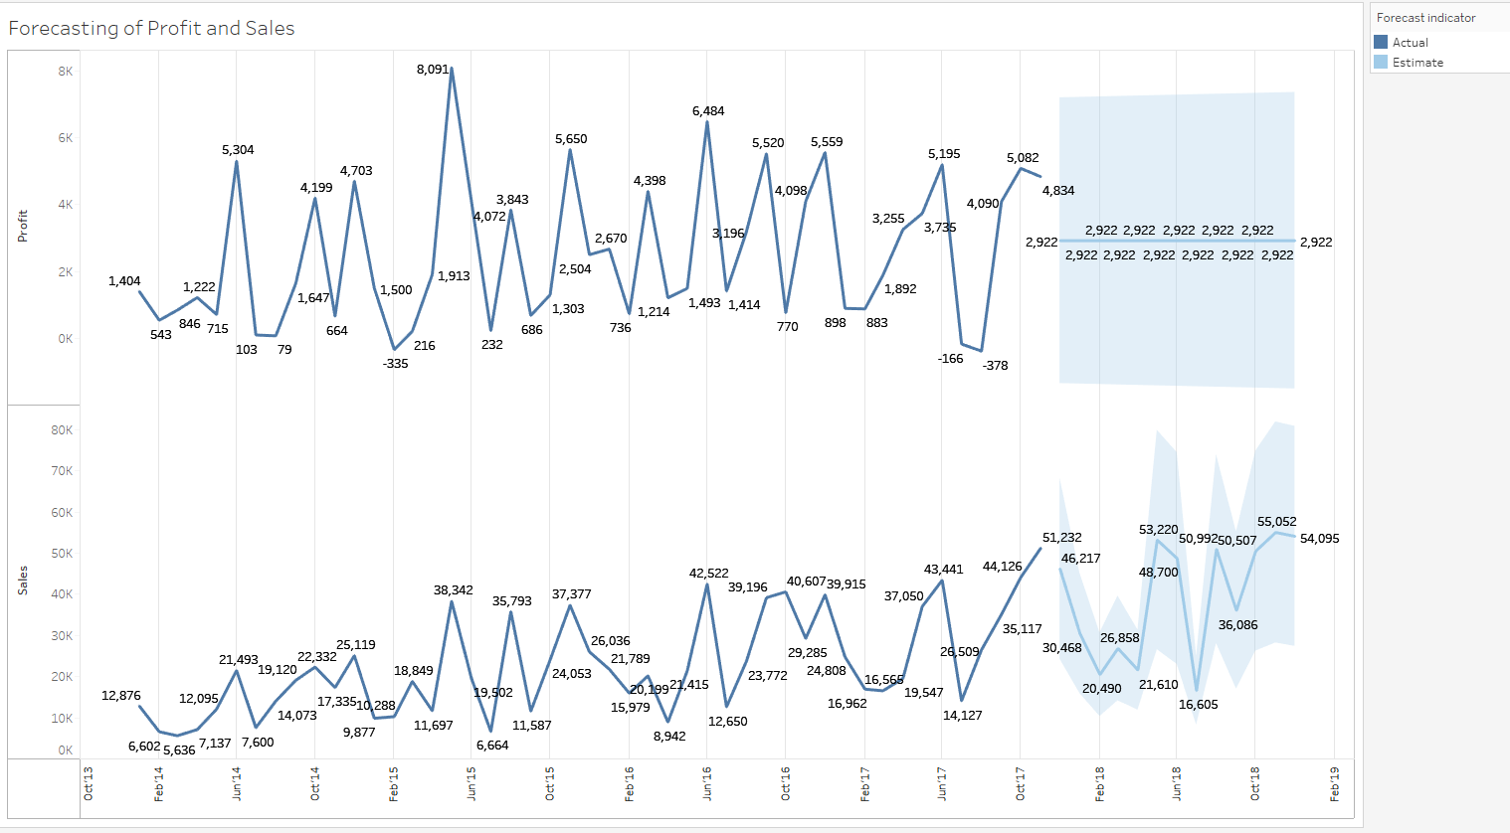

As it can be clearly seen, the forecast for the Sum of Profit for the year of 2018 follows a linear path will be $ 2922 as an average monthly.

But the forecast for Sum of Sales follows the Zig Zag movement starting from December 2017 with $46,217 go down to the lowest in July 2018 to $16,605 and then moving to the highest in November 2018 to $55,052.

# **Appendix**

References:

1. Used analysis techniques provided in the study material of the course.
2. Used Tableau software online help to understand and derive the basic understanding of Visualization (https://onlinehelp.tableau.com)
3. Used advanced analytics of tableau software to derive Trend, Cluster and Forecasting analysis.